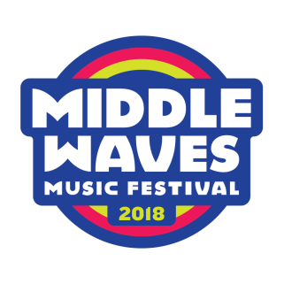

VENDING AGREEMENT – NON-FOOD VENDORS

Middle Waves Music Festival

Friday, September 14th & Saturday, September 15th, 2018

Welcome to Middle Waves 2018!

The Site:
Middle Waves will happen in Headwaters Park on Friday, September 14th and Saturday, September 15th, 2018. MW will feature three stages with two dozen musical performances by national and local musicians, local food trucks and vendors, beverages galore, artists and culture-makers and wild & unexpected good times at every turn.

Festival Hours:
Friday, September 14th 5:00 pm – 11:30 pm
Saturday, September 15th 12:00 pm – 11:15 pm

- Signed agreement and payment is due by August 15th.
There are a limited number of spots available in the main pavilion at Headwaters. Premium placement will be given to the first agreements to be turned in.

- Festival hours are 5:00 pm to 11:30 pm on Friday and 12:00 pm to 11:15 pm on Saturday. Gates open an hour prior on both days. Vendors must be open for business from the time gates open until 9:45pm. Specific load in information, maps, and times will be distributed closer to the festival.

- Vendors are responsible to provide tent or trailer or booth, signage, lighting, staff, table, counter, chairs, trash receptacles– whatever is needed at the site.
PLEASE NOTE: deliveries/loading/unloading will only be allowed during setup hours prior to the festival.

- The festival is held rain or shine and the vending fee paid is non-refundable.

Fees:

Booth Size 10’ x 10’ (if need a different size, please contact vendors@middlewaves.com)

Vendor Fee: $250
Non-Profit Vendor Fee: $150

Vendor Special Priced Tickets:
Vendors at the 2018 Middle Waves Music Festival can get a discounted rate of 25% off of 1 or 2 day passes (maximum of 4 tickets per vendor). If you wish to purchase discounted tickets, please send an email with number of tickets wanted to vendors@middlewaves.com and a special code will be sent for purchase.

Sponsor/ Vibe Partners:
For vendors or companies seeking additional presence at the festival, there are sponsorship/ fan experience opportunities available. Please contact vendors@middlewaves.com for more information.

GUIDELINES AND LIMITATIONS:

-Vendors may not sell any items with the Middle Waves logo. Additionally, vendors may not sell any item with the name or image of any act playing the festival.

-Vendors may not sell any drug paraphernalia, tobacco products, weapons or studded jewelry of any kind.

-Non-Food Vendors are prohibited from selling or giving away any beverages or food items.

INSURANCE: Vendors must maintain at their expense, general liability insurance with an insurance company licensed to do business in the State of Indiana. Middle Waves, LLC must be named as an additional insured party.

INDEPENDENT CONTRACTOR STATUS: Vendors are independent contractors and not employees of the MIDDLE WAVES.

NONCOMPLIANCE: If the MIDDLE WAVES considers a vendor (or member of its staff) to have violated any term or condition of this agreement, the MIDDLE WAVES may remove the vendor and/or member of its staff from the festival with no refund of fees paid.

DISCLAIMER OF LIABILITY: The MIDDLE WAVES is not liable to a vendor or any member of its staff for (a) damage to or loss of any property belonging to or used by the vendor or its staff or (b) any injury suffered by the vendor or members of its staff for any reason.

INDEMNIFICATION: The vendor indemnifies and holds harmless the MIDDLE WAVES, its officers, directors, agents, and members from any claim or other liability arising out of the conduct of the vendor or members of its staff. Vendors will hold the MIDDLE WAVES harmless from any and all liability for the vendor’s acts, errors, and omissions. This includes, but is not limited to, product liability, employment, and operations.

APPROVALS: Any changes or modifications to this agreement must be made in writing and signed by the Middle Waves Vending Chair.

TRADEMARKS: The MIDDLE WAVES reserves the right to exclusive use of the copyrighted trademark “Middle Waves” along with any variations.

ARBITRATION: Any dispute arising under this Agreement will be arbitrated by the American Arbitration Association in the State of Indiana, with all proceedings to be held in Allen County.

Vendor is responsible for all essential items including tents, signage, tables, ice etc. Electrical will be available for additional fees.

2018 Middle Waves VENDOR AGREEMENT – NON-FOOD

Business Name: ___________________________
Contact Name: ____________________________
Phone: ____________________________________
Email: ____________________________________
Company Website/Social Media:
____________________________________

On-site Contact Name: _____________________
On-site Contact Phone: _____________________
FEES: One 10’ x 10’ space Non-Food Vendor Fee: $250
Non Profit Vendor Fee: $150

Electrical Hookup
110v/20 amp _______ @$50 each
If you require a specific electrical requirement not listed, please contact vendors@middlewaves.com. Additional fees may apply.

Will you be using a truck or trailer at your site? _________
If so, please list total length of your truck or trailer? _________

TOTAL FEES: $________

I have received and reviewed the 2018 Vending Agreement in its entirety and agree to its terms and conditions.
Business name ______________________________________________________________
Vendor Signature ___________________________________________________________

CHECK:
Mail with fees before August 15, 2018 to:
Middle Waves, LLC
7604 Idlebrook Dr
Fort Wayne, IN 46835

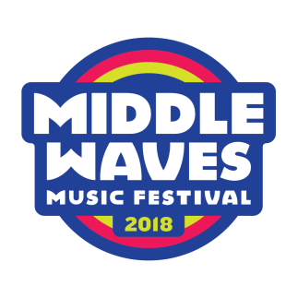

CREDIT CARD:
Please check below if you would prefer to pay with credit card. A Middle Waves Representative will contact you upon receipt for credit card details.

